http://www.mkyong.com/spring
http://websystique.com/springmvc/spring-4-mvc-helloworld-tutorial-annotation-javaconfig-full-example/

What is IOC (or Dependency Injection)?
The basic concept of the Inversion of Control pattern (also known as dependency injection) is that you do not create your objects but describe how they should be created. As a java developer our responsibility is to develop the business component , but creation of object should by the third parties. Like spring framework , so when we need to get a particular component or class we do’t create the object just I request to spring framework and spring framework given me the object that particular component.You don't directly connect your components and services together in code but describe which services are needed by which components in a configuration file. A container (in the case of the Spring framework, the IOC container) is then responsible for hooking it all up.
The IoC container is responsible to instantiate, configure and assemble the objects. The IoC container gets informations from the XML file and works accordingly. The main tasks performed by IoC container are:
- to instantiate the application class
- to configure the object
- to assemble the dependencies between the objects
There are two types of IoC containers. They are:
- BeanFactory
- ApplicationContext
To get the object we need to load this XML file in to spring container for that we need one interface that is Resource and this interface has two classes classes.
- Classpathresource (if our java file and xml file in same folder)
- Filesystemresource (if our java file and xml file in diff folder or dir)
So this interface available in org.spring.core.io.* package

Diff :
BeanFactory is an interface and it’s implementation is XMLBeanFactory class, representing a container that create and provides and manages bean instances. The default implementation instantiates beans lazily(on demand) when getBean() is called.
ApplicationContext is an interface representing a container holding all information, metadata, and beans in the application. It also extends the BeanFactory interface but the default implementation instantiates beans eagerly so as well as application starts beans instantiates automatically.

What are the different types of IOC Injection (dependency injection) ?
There are three types of dependency injection:
- Constructor Injection (e.g. Pico container, Spring etc): Dependencies are provided as constructor parameters.
- Setter Injection (e.g. Spring): Dependencies are assigned through JavaBeans properties (ex: setter methods).
- Interface Injection (e.g. Avalon): Injection is done through an interface.(but it’s not supported in spring it’s supported by struts)

Life cycle of Bean : -When a bean is instantiated, it may be required to perform some initialization to get it into a usable state. Similarly, when the bean is no longer required and is removed from the container, some cleanup may be required. To define setup and down for a bean, we simply declare the <bean> with initmethod and/or destroy-method parameters. The init-method attribute specifies a method that is to be called on the bean immediately upon instantiation. Similarly, destroymethod specifies a method that is called just before a bean is removed from the container.
Example : For Initilization
<bean id = "exampleBean" class = "examples.ExampleBean" init-method = "init"/>
Example : For Destroy
<bean id = "exampleBean" class = "examples.ExampleBean" destroy-method = "destroy"/>

What are the different types of events of Listeners?
You have seen in all the chapters that the core of Spring is the ApplicationContext, which manages the complete life cycle of the beans. The ApplicationContext publishes certain types of events when loading the beans. For example, a ContextStartedEvent is published when the context is started and ContextStoppedEvent is published when the context is stopped.
Following are the different types of events of listeners:
- ContextClosedEvent – This event is called when the context is closed.
- ContextRefreshedEvent – This event is called when context is initialized or refreshed
- RequestHandledEvent – This event is called when the web context handles request

What are the advantages of Spring framework?
The advantages of Spring are as follows:
- Spring has layered architecture. Use what you need and leave you don't need now.
- Spring Enables POJO Programming. There is no behind the scene magic here. POJO programming enables continuous integration and testability.
- Dependency Injection and Inversion of Control Simplifies JDBC
- Open source and no vendor lock-in.

How many modules are there in Spring? What are they?
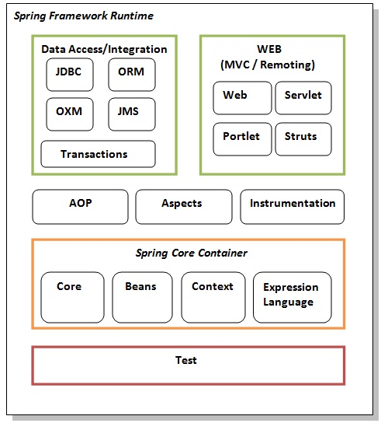

Hibernate and Spring Integration
if we are going to integrate the hibernate application with spring, we don't need to create the hibernate.cfg.xml file. We can provide all the information in the applicationContext.xml file. The Spring framework provides HibernateTemplate class, so you don't need to follow so many steps like create Configuration, BuildSessionFactory, Session, beginning and committing transaction etc.

9. What is Bean Factory ?
A BeanFactory is like a factory class that contains a collection of beans.it is also called basic container because it does not support all the annotations, The BeanFactory holds Bean Definitions of multiple beans within itself and then instantiates the bean whenever asked for by clients.
It is also called lazy loading because first we load the spring configuration file then handover to the container after that we request to create the object of bean class.
- BeanFactory is able to create associations between collaborating objects as they are instantiated. This removes the burden of configuration from bean itself and the beans client.
- BeanFactory also takes part in the life cycle of a bean, making calls to custom initialization and destruction methods.
What is Application Context?
A bean factory is fine to simple applications, but to take advantage of the full power of the Spring framework, you may want to move up to Springs more advanced container, the application context. Application Context Just like as Bean Factory's Big Brother with some additional functionality such as AOP concept, event notification On the surface, an application context is same as a bean factory.Both load bean definitions, wire beans together, and dispense beans upon request. But it also provides:
- A means for resolving text messages, including support for internationalization.
- A generic way to load file resources.
- Events to beans that are registered as listeners.

What are the ways to access Hibernate using Spring ?
There are two approaches to Spring’s Hibernate integration:
- Inversion of Control with a HibernateTemplate and Callback
- Extending HibernateDaoSupport and Applying an AOP Interceptor

How To Load Multiple Spring Bean Configuration File in single unit ?
In a large project structure, the Spring’s bean configuration files are located at different folders for easy maintainability and modular. For example, Spring-Common.xml in common folder, Spring-Connection.xml in connection folder, Spring-ModuleA.xml in ModuleA folder…and etc.
he better way should be organize all your Spring bean configuration files into a single XML file. For example, create a Spring-All-Module.xml file, and import the entire Spring bean files like this
<beans xmlns="http://www.springframework.org/schema/beans"
xmlns:xsi="http://www.w3.org/2001/XMLSchema-instance"
xsi:schemaLocation="http://www.springframework.org/schema/beans
http://www.springframework.org/schema/beans/spring-beans-2.5.xsd">

<import resource="common/Spring-Common.xml"/>
<import resource="connection/Spring-Connection.xml"/>
<import resource="moduleA/Spring-ModuleA.xml"/>

</beans>
Now you can load a single xml file like this :
ApplicationContext context =
new ClassPathXmlApplicationContext(Spring-All-Module.xml);

What are Bean scopes in Spring Framework ?
The Spring Framework supports exactly five scopes (of which three are available only if you are using a web-aware ApplicationContext). The scopes supported are listed below
- singleton – Return a single bean instance per Spring IoC container , it’s is mutable so it’s not thread safe.and it is also stateless.
- prototype – Return a new bean instance each time when requested through getBean(),it is statefull
- request – Return a single bean instance per HTTP request. *
- session – Return a single bean instance per HTTP session. *
- globalSession – Return a single bean instance per global HTTP session.

Example :
<bean id="customer" class="com.spring.Customer" scope="prototype">
Note : we can set scope also on class level using annotation exap:
@Scope(“prototype”
Public class employee
{
}

Q: how to make a bean as thread safe:
Ans:- If you want to make sure your bean is thread-safe, you should go for the @Request Scope. As the name suggests, Spring binds such bean to a particular HTTP web request. So HTTP work every time with new Thread.
But Do you really need all your beans to be thread-safe? Usually, you don’t. Creating a new instance of a bean instead of reusing the existing one is always slower

Q:- What Happen if we Injecting Prototype bean into Singleton Bean
Ans:- be default we got same instance of prototype bean every time if we call it from singleton bean.
So if we want to get actual scope of bean we must use @Lookup annotation with in singleton bean , so if we use this annotation then we got diff - diff scope of prototype bean.
Like:-
Controller:-
@RestController
@RequestMapping("/ScopeTest")
public class ScopeController
{
@Autowired
private ScopeValidator scopevalidator;

@RequestMapping(method=RequestMethod.GET)
public String get()
{
System.out.println(scopevalidator .hashCode()); // it will work as a singleton (same hashcode)
return null;
}

}
Validator Class:-
@Component
@Scope("prototype")
public class ScopeValidator {

}
URL:- http://localhost:8085/ScopeTest
We got same hashcode means if we call prototype bean from default(singleton class) we got same instance.
Now if we use @lookup then we will got actual bean like in this case we got every time diff diff instance.
@RestController
@RequestMapping("/ScopeTest")
public class ScopeController
{
@Autowired
private ScopeValidator scopevalidator;

@RequestMapping(method=RequestMethod.GET)
public String get()
{
System.out.println(getInstanse().hashCode()); // display diff hashcode every time
return null;
}

@Lookup
public ScopeValidator getInstanse()
{
return null;
}
}

Q : What is default scope in Spring?
Ans : Singleton.

Q : Spring Collections
- List – <list/>
- Set – <set/>
- Map – <map/>
- Properties – <props/>

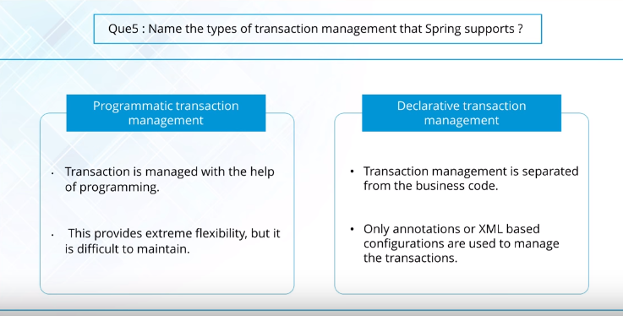

When only a small amount of transactional operations is there, it is advised to use Programmatic transaction management. But if there is a big amount of transactional operations to be taken care of, declarative transaction management is preferred.

Spring Transaction Management JDBC Example :-

We will create a simple Spring JDBC project where we will update multiple tables in a single transaction. The transaction should commit only when all the JDBC statements execute successfully otherwise it should rollback.

If you know JDBC transaction management, you can do it easily by setting auto-commit to false for the connection and based on the result of all the statements, either commit or rollback the transaction. Obviously we can do it but it tightly coupled and non-maintainable code.so we can resolve this problem using transaction Management. Using @Transactional.

For examample suppose we have a class Customer and another class Address. Address use as a forign key in customer table. So if we want that if both table inserted successfully we will commit and aif any one table get exception we will roll back for that we use Transaction annotation.

@Override

@Transactional

public void createCustomer(Customer cust)

{

customerDAO.create(cust);

}

Programeic Transaction –
public class OrderItemClientBean {

@Autowired
private PlatformTransactionManager transactionManager;
@Autowired
private Dao<OrderItem> dao;

public void persistOrderItems() {
TransactionStatus ts =
transactionManager.getTransaction(new DefaultTransactionDefinition());
try {
long id = dao.save(new OrderItem("BWell Ethernet Cable", 5));
System.out.println("id generated: "+id);
id = dao.save(new OrderItem("EDrive SSD", 2000));
System.out.println("id generated: "+id);
transactionManager.commit(ts);
} catch (Exception e) {
transactionManager.rollback(ts);
System.out.println("-- exception message --");
System.err.println(e.getMessage());
System.out.println("---------");
}
System.out.println("loaded items: " + dao.loadAll());

System.out.println("-- second attempt --");
//new transaction boundary
ts = transactionManager.getTransaction(new DefaultTransactionDefinition());
try {
long id = dao.save(new OrderItem("BWell Ethernet Cable", 5));
System.out.println("id generated: "+id);
id = dao.save(new OrderItem("EDrive SSD", 20));
System.out.println("id generated: "+id);
transactionManager.commit(ts);
} catch (Exception e) {
transactionManager.rollback(ts);
System.out.println("-- exception message --");
System.err.println(e.getMessage());
System.out.println("---------");
}
System.out.println("loaded items: " + dao.loadAll());
}
}

Q : What is spring autowiring ?
If autowiring is enabled then spring container will take care about injecting the dependencies, if we want to access the inner bean in outer bean without configure I want direct to access then we can use autowired.by default autowired disabled we need to enable it using autowire nnotation. programmer no need to configure into an xml file explicitly. If autowiring is disabled in spring framework. It means the programmer has to explicitly wire the bean properties into an xml file.In Spring, “Autowiring by Name” means, if the name of a bean is same as the name of other bean property, auto wire it. In Spring, 5 Auto-wiring modes are supported.
- no – Default, no auto wiring, set it manually via “ref” attribute
- byName – Auto wiring by property name. If the name of a bean is same as the name of other bean property, auto wire it. It internally calls the setter method.
- byType – Auto wiring by property data type. If data type of a bean is compatible with the data type of other bean property, auto wire it. It internally calls the setter method.
- constructor – byType mode in constructor argument.
- autodetect – If a default constructor is found, use “autowired by constructor”; Otherwise, use “autowire by type”.
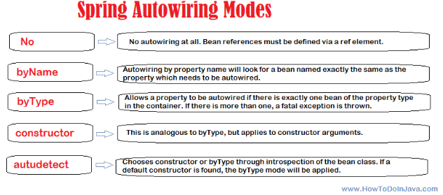

If we want to make a program without Autowired then we need to define every thing explicitly using ref attribute like that.
public class MYA
{
public MYB bObj;

public MYB getbObj() {
return bObj;
}

public void setbObj(MYB bObj)
{
this.bObj = bObj;
}

}
public class MYB
{
public void display()
{
System.out.println("MYB called");
}

}
<bean id="a1" class="com.spring.autowired.MYA">
<property name="bObj" ref="b1">
</property>
</bean>
<bean id="b1" class="com.spring.autowired.MYB"/>

ByName : in case of autowire byname the properties of a class should be same in configuration,xml file. Like we can see that there is a Address class inside Employee class. So here Address property is address so this should be same name in xml file.
public class Employee
{
public int id;
public String empName;
public Address address;

public Employee(int id,Address address,String empName) {
super();
this.id = id;
this.address = address;

this.empName = empName;

}

public Employee(int id, String empName) {
super();
this.id = id;
this.empName = empName;
}

public Employee()
{
System.out.println("Const is called");
}
public int getId() {
return id;
}
public void setId(int id) {
this.id = id;
}
public String getEmpName() {
return empName;
}
public void setEmpName(String empName) {
this.empName = empName;
}

public Address getAddress() {
return address;
}
public void setAddress(Address address) {
this.address = address;
}
@Override
public String toString() {
return "Employee [id=" + id + ", empName=" + empName + ", address=" + address + "]";
}
}

public class Address
{
private String city;
private String state;
public String getCity() {
return city;
}
public void setCity(String city) {
this.city = city;
}
public String getState() {
return state;
}
public void setState(String state) {
this.state = state;
}
public Address() {
super();
}

}

<bean id="empBean1" class="com.spring.Employee" autowire="byName">
<property name="id" value="1"></property>
<property name="empName" value="rahul"></property>
</bean>
<bean id="address" class="com.spring.Address">
<property name="city" value="delhi2"></property>
<property name="state" value="Delhi"></property>
</bean>

ByType : in case of byType autowire not necessary that properties name should be same in xml file but class name should be same like we have Address class the in xml file clas= com.spring.Address should be same:
<bean id="empBean1" class="com.spring.Employee" autowire="byType">
<property name="id" value="1"></property>
<property name="empName" value="rahul"></property>
</bean>
<bean id="address1" class="com.spring.Address">
<property name="city" value="delhi2"></property>
<property name="state" value="Delhi"></property>
</bean>

Note : Another way to use Autowired using annotation on setterMethod @ Autowired is treat by default as a bytype autowire , we must enable
<bean class="org.springframework.beans.factory.annotation.AutowiredAnnotationBeanPostProcessor"/> in configuration file.

Spring @Qualifier: As we learned that if we are using autowiring in ‘byType‘ mode , in that case bean is biend bu type not byname so if two bean have with same type then there be a chance of data colosion so reduce this problem we use @Qualifier., we need to use @Qualifier annotation along with @Autowiredannotation and pass the bean name in annotation parameter.
public class Employee
{
public int id;
public String empName;
@Autowired
@Qualifier("address2")
public Address address;
}

<bean id="empBean1" class="com.spring.Employee" autowire="byType">
<property name="id" value="1"></property>
<property name="empName" value="rahul"></property>
</bean>
<bean id="address1" class="com.spring.Address">
<property name="city" value="delhi2"></property>
<property name="state" value="Delhi"></property>
</bean>

<bean id="address2" class="com.spring.Address">
<property name="city" value="delhi2"></property>
<property name="state" value="Delhi"></property>
</bean>

Spring Interceptor : - generally interceptor is used if we want to perform some task before handling a request . for example suppose we want to prevent my application access on Sunday. Means I want that users can access my application in 6 days in a week but not sunday.for that we need to follow below point.
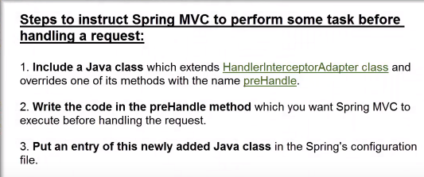
Example :
public class DayBasedAccessUsingInterceptor extends HandlerInterceptorAdapter
{
@Overridepublic boolean preHandle(HttpServletRequest request, HttpServletResponse response, Object handler)throws Exception {

Calendar cal = Calendar.getInstance();
int dayOfWeek = cal.get(cal.DAY_OF_WEEK);
if(dayOfWeek == 1) // 1 means Sunday
{
response.getWriter().write("This website is closed on sunday : please try another day");
return false;
}

return true;
}}

Add this class in configuration.xml file : --
<mvc:interceptors>
<bean class="com.spring.controller.DayBasedAccessUsingInterceptor"/>
</mvc:interceptors>

The above example will not open this whole application(include every page) on Sunday only but if I want to set interceptor on a particular page or particular URL request instead of whole application then we need add one more line .we need to set the path of particular URL page.
<mvc:interceptors>
<mvc:mapping path=”/admission.html”/>
<bean class="com.spring.controller.DayBasedAccessUsingInterceptor"/>
</mvc:interceptors>

Spring Validation : - if we want to validate a particular field of model , we can use some annotation like :-
Step-1 : -
@Size(min=3,max=6,message="please enter value for password between 3 to 6")
private String password;

@Pattern(regexp="[^0-9]*")
private String username;

Step:2 : - we need to set Bindingresult and @Valid annotation

@RequestMapping(value="/registerProcess",method=RequestMethod.POST)
public ModelAndView RegisterProcess(@Valid @ModelAttribute("user")User user,BindingResult resut) {
if(resut.hasErrors())
{
ModelAndView mv = new ModelAndView("user");
return mv;
}
ModelAndView mv = new ModelAndView("welcome");
return mv;
}

SimpleFormController
SimpleFormController is very useful in case where you want to send lots of inputs from a form to persist, i.e., if you are required to perform a task that requires lets say 20 to 30 inputs of different types from the user and submit this form for your own business logic and persistence for latter retrieval.
In traditional jsp and servlet way
You will create a form using html having a all required inputs with a servlet mapped as its action
Take inputs from the users and submit to a servlet
Then it will use the HttpServletRequest to get all the parameters for further processing
It’s a hectic job to get all 20 or 30 fields putting them in a collection (although we can use beans in traditional jsps) or an object like BO and then perform the actual task on this data.
But in case of spring’s SimpleFormController this whole process becomes very short as you only need to map a class to the jsp and this will be available to you will the inputs in the controller. It eliminates the hectic job of using HttpServlerRequest and fetching all the parameters one by one.

MultiActionController
If you want to perform some related tasks like manipulation of client entity, i.e., you want to add client’s info into the system, modify existing client, or want to view all the existing clients, then MultiActionController would be the better choice as you requires almost same functionality with a little bit difference. So instead of rewriting the same code for the same functionality just showing the page (one for addClient, one for modifyClient, and one for viewClient) create a class having multiactioncontrolller functionality and display all these three pages using a single controller.
It lessens your dispatcher entries; make all the functionality starting at the same point. After some time if you need to review this processes you shouldn’t need to search out how many controllers did you developed.

Annotation Controller

@Controller
@RequestMapping("/userRegistration.htm")
@SessionAttributes("user")
public class UserController {

private UserService userService;

@Autowired
public void setUserService(UserService userService) {
this.userService = userService;
}

@RequestMapping(method = RequestMethod.GET)
public String showUserForm(ModelMap model) {
User user = new User();
model.addAttribute(user);
return "userForm";
}

@RequestMapping(method = RequestMethod.POST)
public String onSubmit(@ModelAttribute("user") User user) {
userService.add(user);
return "redirect:userSuccess.htm";
}

}
The @Controller annotation is used to mark any java class as a controller class.
The @RequestMapping annotation is used to map the web request "/userRegistration.htm" to theUserController class.
The @SessionAttributes annotation is used to store the model object in the session. In our case the model object is user.
Using the @Autowired annotation the container can wire your beans automatically. By default autowire is done by type. Here any class that is compatible with UserService class will be chosen.
In the controller class you need to specify two methods, one for handling the HTTP GET request and the other for handling the HTTP POST request. These methods can have arbitrary names. When the form is first rendered the showUserForm() method will be invoked and when the form is submitted for processing the onSubmit() method will be invoked.
The @RequestMapping annotation is used to indicate the type of HTTP request.
After the form is filled and submitted the onSubmit() method will be called. You can access the command object using the @ModelAttribute annotation. Here the command object name is user, the one that we set in the ModelMap. After getting the command object, call the service method to register the user and redirect the control to the "userSuccess.jsp" page.

Q-Life Cycle Of Bean
The life cycle of a Spring bean is easy to understand. When a bean is instantiated, it may be required to perform some initialization to get it into a usable state. Similarly, when the bean is no longer required and is removed from the container, some cleanup may be required.
we simply declare the <bean> with init-method and/ordestroy-method parameters. The init-method attribute specifies a method that is to be called on the bean immediately upon instantiation. Similarly, destroy-method specifies a method that is called just before a bean is removed from the container.
Ex :- <bean id="exampleBean"
class="examples.ExampleBean" init-method="init"/>
Following is the class definition:
public class ExampleBean {
public void init() {
// do some initialization work
}
}

Q19. How to Get ServletContext and ServletConfig Objects in a Spring Bean?
Your bean may implement ServletContextAware and ServletConfigAware interfaces and override the setServletContext() and setServletConfig() methods.
@Controller
@RequestMapping(value = "/home")
public class HomeController implements ServletContextAware, ServletConfigAware {

private ServletContext context;
private ServletConfig config;

@Override
public void setServletConfig( ServletConfig servletConfig) {
this.config = servletConfig;

}

@Override
public void setServletContext(ServletContext servletContext) {
this.context = servletContext;
}

}

What is the role of the @Required annotation?
The @Required annotation is used on setter methods, and it indicates that the bean property that has this annotation must be populated at configuration time. Otherwise, the Spring container will throw a BeanInitializationException exception.
public class Person {
private String name;

@Required
public void setName(String name) {
this.name = name;
}
}
Now, the name of the Person bean needs to be set in XML config like this:
1  2  3 | <bean id="person" class="com.baeldung.Person">  <property name="name" value="Joe" />  </bean>

Q22. What is the Role of the @Qualifier Annotation?
It is used simultaneously with the @Autowired annotation to avoid confusion when multiple instances of a bean type are present.
Let’s see an example. We declared two similar beans in XML config:
1  2  3  4  5  6 | <bean id="person1" class="com.baeldung.Person" >  <property name="name" value="Joe" />  </bean>  <bean id="person2" class="com.baeldung.Person" >  <property name="name" value="Doe" />  </bean>
When we try to wire the bean, we’ll get an org.springframework.beans.factory.NoSuchBeanDefinitionException. To fix it, we need to use @Qualifier to tell Spring about which bean should be wired:
1  2  3 | @Autowired  @Qualifier("person1")  private Person person;

How to handle exceptions in Spring MVC environment?
- Using @ExceptionHandler at controller level – this approach has a major feature – the @ExceptionHandler annotated method is only active for that particular controller, not globally for the entire application.it is a comma separated exception handler like:-
@ExceptionHandler({IOException.class,ArithmeticException.class})
Note: we need to create a JSP ExceptionHandller.jsp
- @RequestMapping("/user1")
- public ModelAndView user(HttpServletRequest req,HttpServletResponse res)throws Exception
- {
- String userName = req.getParameter("userName");
- if(userName == null || userName == "")
- {
- throw new Exception();
- }
- ModelAndView mv = new ModelAndView();
- mv.setViewName("user");
- mv.addObject(userName);
- return mv;
- }

- @ExceptionHandler(value=Exception.class)
- public String handleException(Exception e)
- {
- return "ExceptionHandller"; // this is jsp name
- }

- Using HandlerExceptionResolver – this will resolve any exception thrown by the application

JSP

Forward:-

When the forward is done, the original request and response objects are transfered along with additional parameters if needed. This transfer of control is done by the container internally and browser / client is not involved

Redirect :-

Control can be redirect to resources to different servers or domainsThis transfer of control task is delegated to the browser by the container. That is, the redirect sends a header back to the browser / client. This header contains the resource url to be redirected by the browser. Then the browser initiates a new request to the given url. Since it is a new request, the old request and response object is lost. For example, sendRedirect can transfer control from http://javapapers.com to http://anydomain.com but forward cannot do this.

To feel the difference between forward and sendRedirect visually see the address bar of your browser,
in forward, you will not see the forwarded address (since the browser is not involved)
in redirect, you can see the redirected address.

Exception Handling in Spring :
There are two way two handle exception in spring 1) globel exception handler 2) individual exception handling
1)Individual Class : in this way we must handle exception in every class(controller) using @ExceptionHandler annotation.
Steps :-
1.create a controller to handle exception
@Controller
public class LoginController
{
@RequestMapping(value = "/login", method = RequestMethod.GET)
public ModelAndView showLogin(HttpServletRequest request, HttpServletResponse response) throws Exception
{
String except = "NullException";
if(except.equals("NullException"))
{
throw new NullPointerException();
}
else if(except.equals("Exception"))
{
throw new Exception();
}
ModelAndView mav = new ModelAndView("login");
mav.addObject("login", new Login());
return mav;
}

@ExceptionHandler(value=Exception.class)
public String handlerException(Exception e)
{
return "Exception"; // this is return jsp name
}
@ExceptionHandler(value=NullPointerException.class)
public String handlerNullException(Exception e)
{
return "NullException";
}
}
2.create jsp files to display exceptions
NullException.jsp :-
<h1>Null Pointer Exception occured......</h1>
Exception.jsp
<h1> Exception occured......</h1>
2) Globel Class : another way to handle the exception we must create a globel class and it should be capable to handle all type of exception.now paste all exception handler methods from previous class in this class.
@ControllerAdvice
public class GlobelExceptionHandler
{
// @ExceptionHandler(Exception.class)
// public String handlerException(Exception e)
// {
// return "Exception";
// }

@ExceptionHandler(value=RuntimeException.class)
public String handlerNullException()
{
return "NullException";
}

}
@

Q : -Diff between @sessionAttribute and @sessionAttributes in spring : -
@SessionAttributes annotation is used to store the model attribute in the session. This annotation is used at controller class level.
@SessionAttributes("user")
public class LoginController
{
@ModelAttribute("user")
public User setUpUserForm()
{
return new User();
} }
In the above code, the model attribute ‘user’ will be added to the session if the name attribute of the @ModelAttribute and @SessionAttributes annotations is same.
On an incoming request, any methods annotated with @ModelAttribute are called before any controller handler other method. In actually, what @SessionAttributes allows you to do is tell Spring which of your model attributes will also be copied to HttpSession before rendering the view.
@SessionAttribute annotation is used to retrieve the existing attribute from session that is managed globally and it is used at method parameter as shown follows.
@GetMapping("/info")
public String userInfo(@SessionAttribute("user") User user)
{
//... //... return "user";
}

Diff between Setter Injection and Constructor Injection : -
1) Setter injection is partial injection but constructor is not ,Suppose there are 3 properties in a class, having 3 arg constructor and setters methods. In such case, if you want to pass information for only one property, it is possible by setter method only.
2) We can easily change the value by setter injection. It doesn't create a new bean instance always like constructor. So setter injection is flexible than constructor injection.
3) Setter Injection will overrides the constructor injection value, provided if we write setter and constructor injection for the same property. But, constructor injection cannot overrides the setter injected values.

Diff Between @Resource ,@Inject , @Autowired:-
Spring Hibernate Integeration : -
In hibernate framework, we provide all the database information hibernate.cfg.xml file.But if we are going to integrate the hibernate application with spring, we don't need to create the hibernate.cfg.xml file. We can provide all the information in the applicationContext.xml file. The Spring framework provides HibernateTemplate class, so you don't need to follow so many steps like create Configuration, BuildSessionFactory, Session, beginning and committing transaction etc. So it saves a lot of code. You can simply write this:
NOTE :- Hibernate Template is thread safe and reusable. You need not manually open and close Session,
Employee e1=new Employee(111,"arun",40000);
hibernateTemplate.save(e1);

Let's see a list of commonly used methods of HibernateTemplate class.
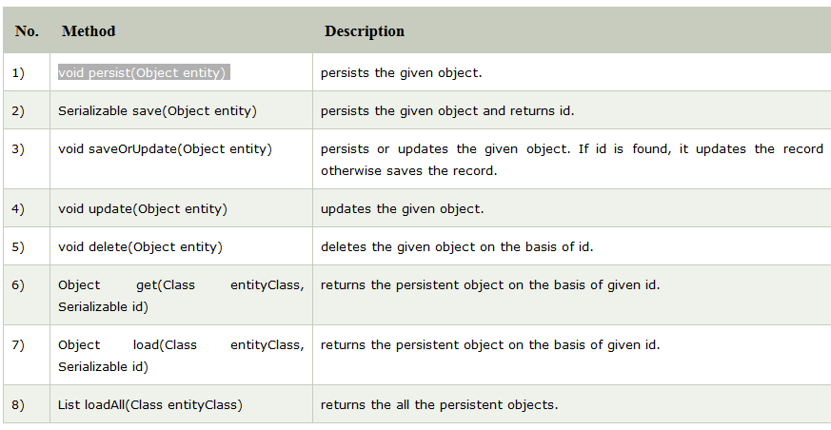

Steps
Let's see what are the simple steps for hibernate and spring integration:
- create table in the database It is optional.
- create applicationContext.xml file It contains information of DataSource, SessionFactory etc.
- create EmployeeEntity.java file It is the persistent class
- create EmployeeDao.java file It is the dao class that uses HibernateTemplate.
- create EmployeeDaoImplementation.java file It calls methods of EmployeeDao class.

Spring Security : -
To implement security in spring framework we have to use some kind of filter proxy. And the main proxy is Deligatingfilterproxy. the spring security based on servlet filters. That is managed by servlet container , and we know that if we are going to implement servlet filter we need to configure it in WEB.xml .so we can say that Deligatingfilterproxy is a bridge between the servlet container and your application context.so Deligatingfilterproxy deligate to filterchainproxy and filterchainproxy take care of all filters that you are creating in applicationcontext.

SPRING BOOT

Q: How Spring boot work internally :
Ans:-when we create a spring boot application first of all we need to create some starter pom that has all the jars like spring-boot-starter.web etc. these jar has some spring.factories under META-INF folder. These jar decide what should be enable and what should be disable at run time based on @conditional and @Configuration.
After create a boot application there is a main class created that has a annotation @Spring BootApplication.
this annotation internally contain 3 more annotation.
@Spring BootApplication = @Configuration+@EnableAutoConfiguration+@ComponentScan.
  - @Configuration :- This annotation marks a class as a Configuration class that is java based configuration over xml based configuration this class has more than one @Bean method.
  - @ComponentScan
  - @EnableAutoconfiguration:- this annotation auto-configures the beans that are present in the classpath. For example, if you have tomcat-embedded.jar in the classpath, then you will need a TomcatEmbeddedServletContainerFactory bean to configure the tomcat server. This will be searched and configured without any manual XML configurations.
OR
This annotation tells Spring to automatically configure your application based on the dependencies that you have added in the pom.xml file. For example, If spring-data-jpa or spring-jdbc is in the classpath, then it automatically tries to configure a DataSource by reading the database properties from application.properties file.

Q: how to kick the spring boot application:
Ans: there is a main method so inside the main method there is run()
SpringApplication.run(SpringBootExampleApplication.class, args);

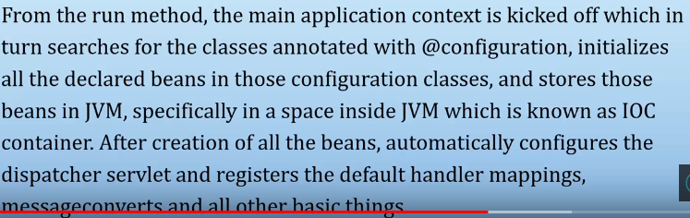
So if we talk the internal working of run() it is
  - create application context
  - check application type(it is web based or standalone etc)
  - Register the annotated class bean with the context
  - Create an instance of Tomcat and add the context

Spring Boot Component : -

Spring Boot Framework has mainly four major Components.

Spring Boot Starters
Spring Boot AutoConfigurator
Spring Boot CLI
Spring Boot Actuator
NOTE:-
In addition to these four major components, there are two more Spring Boot components:
Spring Initilizr
Spring Boot IDEs
To quick start new Spring Boot projects, we can use “Spring Initializr” web interface. Spring Initializr URL: http://start.spring.io.
We have many Spring Boot IDEs like Eclipse IDE, IntelliJ IDEA, Spring STS Suite etc. We will discuss these two components in coming posts.

Q: @Bean Annotation:
Ans:- @Bean is a method-level annotation and it will execute that method and register the return value as a bean within a BeanFactory.The class where @bean used this class should be use @configuration annotation.
NOTE :- Defauly Autowire of bean is “byType” in Spring Boot
@Configuration
public class MyConfiguration
{
@Bean
public MyBean getBean()
{
return new MyBean();
}
}

public class MyBean
{
public MyBean()
{
System.out.println("instance myBean() created...");
}

}
public class Main
{
public static void main(String ar[])
{
AnnotationConfigApplicationContext ctx = new AnnotationConfigApplicationContext();
ctx.register(MyConfiguration.class);
ctx.refresh();
//MyBean bean1 = ctx.getBean(MyBean.class);
//MyBean bean2 = ctx.getBean(MyBean.class);
ctx.close();
}

}
Output :-
instance myBean() created...
As well as we run main class , MyConfiguration class load into context and the instance of bean is created automatically. Notice that Spring loads the beans into it’s context before we have even requested it. If you uncomment the statements where I am getting MyBean instances, you will notice that it’s not calling the constructor of MyBean. It’s because the default scope of spring beans is Singleton. We can change it using @Scope annotation.

2nd if we change scope like
@Configuration
public class MyConfiguration
{
@Bean
@Scope("prototype")
public MyBean getBean()
{
return new MyBean();
}
}

public class Main
{
public static void main(String ar[])
{
AnnotationConfigApplicationContext ctx = new AnnotationConfigApplicationContext();
ctx.register(MyConfiguration.class);
ctx.refresh();
MyBean bean1 = ctx.getBean(MyBean.class);
MyBean bean2 = ctx.getBean(MyBean.class);
ctx.close();
}
}
Ouput:-
instance myBean() created...
instance myBean() created...

Q:- How to use Qualifier in Spring Boot :-
Ans:- we know that we required qualifier when multiple instances of a bean are present.in spring boot by default autowired type is “bytype” like:- as we can see given example has two instance of
VechicalImpl so here spring will confused that which object called.

@Configuration
public class MyConfiguration
{

@Bean
public Car getCarColor()
{
return new Car();
}

@Bean(name="vechical1")
public VechicalImpl getVechical1()
{
return new VechicalImpl();
}

@Bean(name="vechical2")
public VechicalImpl getVechical2()
{
return new VechicalImpl();
}

}

@Component
public class Car
{
@Autowired
@Qualifier("vechical2")
Vechical vechical;

public Vechical getVechical() {
return vechical;
}
public void setVechical(Vechical vechical) {
this.vechical = vechical;
}

public void displayInformation()
{
vechical.setColor("Red");
System.out.println("Car Color is : "+vechical.getColor());
}

}

public interface Vechical
{

public void setColor(String color);
public String getColor();

}

public class VechicalImpl implements Vechical
{
private String color;

@Override
public void setColor(String color) {
this.color = color;

}

@Override
public String getColor() {
return color;
}

}

public class Main
{
public static void main(String ar[])
{
AnnotationConfigApplicationContext ctx = new AnnotationConfigApplicationContext();
ctx.register(MyConfiguration.class);
ctx.refresh();
Car car = ctx.getBean(Car.class);
car.displayInformation();
ctx.close();
}
}

Q: what happen if we do’t use @Configuration with our class Like.
Ans: in this case, if we make a call to myBean() method then it will be a plain java method call and we will get a new instance of MyBean every time and it won’t remain singleton.

public class MyConfiguration
{
@Bean
public MyBean getBean()
{

return new MyBean();

}
@Bean
public MyBeanConsumer beanConsumer()
{
return new MyBeanConsumer(getBean()); // it again create MyBean object
}
}
public class MyBean
{
public MyBean()
{
System.out.println("instance myBean() created...");
}

}
public class MyBeanConsumer
{
public MyBeanConsumer(MyBean bean)
{
System.out.println("hashcode : "+bean.hashCode());
}
}
public class Main
{
public static void main(String ar[])
{
AnnotationConfigApplicationContext ctx = new AnnotationConfigApplicationContext();
ctx.register(MyConfiguration.class);
ctx.refresh();
MyBean bean1 = ctx.getBean(MyBean.class);
MyBean bean2 = ctx.getBean(MyBean.class);

ctx.close();
}
}
Output : -
instance myBean() created...
instance myBean() created...
hashcode : 863125040

Q:-debug autoconfiguration :-
Ans: there are 2 way to debug autoconfiguration
1). Turrning on debug logging
2).Using SpringBoot Actuator
1. Turning Debug Logging:
We need to add property value in application.property file
Logging.level.org.springframework: DEBUG
After that restart the applicationyou would see auto configuration report in the logs

Q: what is exclude():You can always manually exclude() any configuration that you never want to apply
Or we can say that if we want to disable a particular class to make a Auto configuration class
Example :- @SpringBootApplication(exclude=HibernateJpaAutoConfiguration.class)

How to disable a specific auto-configuration class?
Ans:- @EnableAutoConfiguration(exclude={DataSourceAutoConfiguration.class})
Or in application.properties file
spring.autoconfigure.exclude=org.springframework.boot.autoconfigure.jdbc.DataSourceAutoConfiguration

Can we override or replace the Embedded Tomcat server in Spring Boot?
Yes, we can replace the Embedded Tomcat with any other servers by using the Starter dependencies. You can use spring-boot-starter-jetty or spring-boot-starter-undertow as a dependency for each project as you need. Spring Boot support three embedded containers: Tomcat, Jetty, and Undertow. By default, it uses Tomcat as embedded containers but you can change it to Jetty or Undertow.

Can we disable the default web server in the Spring Boot application?
Yes, we can use the application.properties to configure the web application type, i.e. spring.main.web-application-type=none.

How to Register a Custom Auto-Configuration?
To register an auto-configuration class, we must have its fully-qualified name listed under the EnableAutoConfiguration key in the META-INF/spring.factories file:like
org.springframework.boot.autoconfigure.EnableAutoConfiguration=com.baeldung.autoconfigure.CustomAutoConfiguration

how DispatcherServlet configure in Spring Boot?
As soon as we added in Spring Boot Starter- Web as a dependency in our project, Spring Boot Autoconfiguration sees that Spring MVC is on the classpath. It autoconfigures dispatcherServlet.

Q-1 : how to configure database in springboot
Ans: we know that in spring boot there is no config file , so we need a properties file and a java class . in properties file we define all DB related information and in Java file we need to configure this properties file values with the help of @Configuration and @Bean annotations like:
1).Application.properties
db.driver: com.mysql.cj.jdbc.Driver
db.url: jdbc:mysql://localhost:3306/prod_managmentdb
db.username: root
db.password: root

2). Java file
@Configuration
@EnableTransactionManagement
public class DBConfiguration
{

@Value("${db.driver}")
private String DRIVER;

@Value("${db.password}")
private String PASSWORD;

@Value("${db.url}")
private String URL;

@Value("${db.username}")
private String USERNAME;

@Bean
public DataSource dataSource() {
DriverManagerDataSource dataSource = new DriverManagerDataSource();
dataSource.setDriverClassName(DRIVER);
dataSource.setUrl(URL);
dataSource.setUsername(USERNAME);
dataSource.setPassword(PASSWORD);
return dataSource;
}

@Bean
public LocalSessionFactoryBean sessionFactory() {
LocalSessionFactoryBean sessionFactory = new LocalSessionFactoryBean();
sessionFactory.setDataSource(dataSource());
sessionFactory.setPackagesToScan(PACKAGES_TO_SCAN);
Properties hibernateProperties = new Properties();
hibernateProperties.put("hibernate.dialect", DIALECT);
hibernateProperties.put("hibernate.show_sql", SHOW_SQL);
hibernateProperties.put("hibernate.hbm2ddl.auto", HBM2DDL_AUTO);
sessionFactory.setHibernateProperties(hibernateProperties);

return sessionFactory;
}
}

@Service annotation : -@Service annotation is used with a class so that spring context can autodetect it and we can get its instance from the context.
For example :-
package com.journaldev.spring;
import org.springframework.stereotype.Service;

@Service
public class MathService {

public int add(int x, int y) {
return x + y;
}

}
Notice that it’s a simple java class that provides functionalities to add two integers. So we can call it a service provider. We have annotated it with @Service annotation so that spring context can autodetect it and we can get its instance from the context.
public class SpringMainClass {

public static void main(String[] args) {
AnnotationConfigApplicationContext context = new AnnotationConfigApplicationContext();
context.scan("com.journaldev.spring");
context.refresh();

MathService ms = context.getBean(MathService.class);

int add = ms.add(1, 2);
}
}

Note :- same this happen is spring boot if we define a class as a@service then we can it autowired any where.
The @Service annotation is also a specialization of the @component annotation. It doesn’t currently provide any additional behavior over the @Component annotation both just like same, but it’s a good idea to use @Service over @Component in service-layer classes.

@component : -The @Component annotation marks a java class as a bean so the component-scanning mechanism of spring can pick it up and pull it into the application context.

Q-2 : how to create and call multiple .properties file in spring boot
Ans: we know that in spring boot there is one default Application.properties file , we can create multiple properties file like:
Suppose I have MyTest.properties file and I want to use it , so to call this we need a java file and put annotation “@PropertySource("classpath:mytest.properties")”

1).
@Configuration
@PropertySource("classpath:mytest.properties")
public class MyConfigure
{
@Value("${db.driver}")
private String DRIVER;

@Bean
public String getDriver()
{
return DRIVER;
}

}
2). To access DRIVER value in any class we use @Autowired annotation like:
Class call
{
@Autowired
String getDriver;
System.out.println(getDriver);

}

Q:-3 what is Actuator in spring boot?
Ans: As we know, Spring Boot provides lots of auto-configuration features that help developers quickly develop production components. But if you think about debugging and how to debug or we can say that if we want to monitor internal things than we can use Actuator. For that we need to enable this.
<dependencies>
<dependency>
<groupId>org.springframework.boot</groupId>
<artifactId>spring-boot-starter-actuator</artifactId>
</dependency>
</dependencies>

MicroServices:-

Eureka Server :- Eureka Server is an application that holds the information about all client-service applications. Every Micro service will register into the Eureka server and Eureka server knows all the client applications running on each port and IP address. Eureka Server is also known as Discovery Server. It run on the default port 8761. we need to add @EnableEurekaServer annotation.

Ribbon :- it is used for load balancing at client side. load balancing improves the distribution of workloads across multiple computing resources. Suppose we developed two services employee-producer and employee-consumer. Suppose other modules are also calling and consuming employee-producer module services. So the load at employee-producer is high. To deal with this we this we deploy multiple instances of employee-producer. Suppose two in this case. Now we will have to use a Load Balancer to route any incoming requests to either one of these two services.
<dependency>
<groupId>org.springframework.cloud</groupId>
<artifactId>spring-cloud-starter-ribbon</artifactId>
</dependency>

Add in properties file-
eureka.instance.instanceId=${spring.application.name}:${random.int}
and use in class
@Autowired
private LoadBalancerClient loadBalancer;
ServiceInstance serviceInstance=loadBalancer.choose("app-producer");

What Is a Zuul Proxy:- in a complex business domain, more than 50-100 microservices is very common. Let's imagine a system where we have fifty microservices now we have to implement a UI which is kind of a dashboard, so it calls multiple services to fetch and show the important information in the UI. From a UI developer perspective, to collect information from fifty underlying microservices, it has to call fifty REST APIs, as each microservice exposes a REST API for communication. So the client has to know the details of all REST API and URL patterns/ports to call them.

So if we want to implement security, authentication, monitoring etc , we must implement each and every service. so the same code has been replicated over fifty microservices.

To make it robust, it has to be changed in such way so that we have only one entry point where all common aspects code is written and the client communicates with that common service. Here, the Zuul (The Gatekeeper/Demigod) concept pops up.
Zuul acts as an API gateway or Edge service. It receives all the requests coming from the UI and then delegates the requests to internal microservices. So, we have to create a brand new microservice which is Zuul-enabled, and this service sits on top of all other microservices.

Q- how to find out from multiple micro services that which service getting problem.
Ans:- if we have multiple microservice so we need to create a centerlized logger system that get logs from all the microservices. For that we have 3 technologies (ELK)
1. ElasticSearch: Elasticsearch is a NoSQL database that is based on the Lucene search engine
2. LogStash: Logstash is a log pipeline tool that accepts inputs from various sources
3. Kibana: Kibana is a visualization UI layer that works on top of Elasticsearch

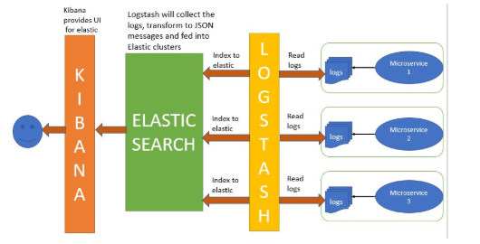

CoRelation-Id:-Another way to find out the root cause of problem , we should use MDC(Mapped Diagnostic Context). We know that microservice that serves HTTP requests. So we need a CoRelation id and put in every Http request. First, we will be creating a request interceptor. This interceptor will check request headers first to see if a correlation id exists. If not, then it will create a new correlation id. Then it will put the correlation id into the MDC and remove it after the request completes.

Q:- Authentication and Authorization:-
- Ans:- Authentication: Refers to verify who you are, so you need to use username and password for authentication.
- Authorization: Refers to what you can do, for example access, edit or delete permissions to some documents, and this happens after verification passes.

Q: Token based Authentication or security in SpringBoot
Ans:-to make a secure web based spring boot application we need to implement
OAuth(Open Authorization).

OAuth2
OAuth is simply a secure authorization protocol that deals with the authorization of third party application to access the user data without exposing their password or we can say that OAuth2 is an authorization framework that enables the application Web Security to access the resources from the client. To build an OAuth2 application, we need to focus on the Grant Type (Authorization code), Client ID and Client secret.
So basically there are main 4 protocols that used in Oauth
- Resource Owner - This is the user who wants to sign up.
- Client Application - This will be Client application
- Resource Server - This will be 3rd party servers like Gmail or Facebook.
- Authorization Server - The resource server hosts the protected user accounts, and the authorization server verifies the identity of the user then issues access tokens to the application.
The client application must first register with the authorization server associated with the resource server. At registration the client application is assigned a client ID and a client secret (password) by the authorization server. The client ID and secret is unique to the client application on that authorization server.

1. Authorization Code Grant
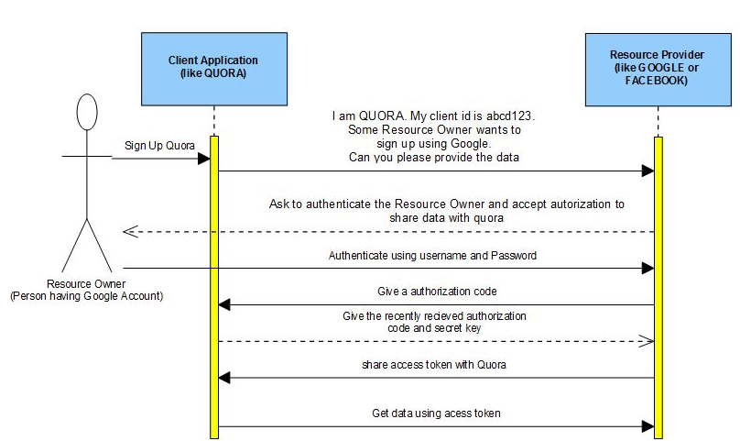
Authorization Code Grant
- The Resource Owner will ask the Client Application to get some data from the Resource Server.
- The Resource Server asks the Resource Owner to authenticate itself and as for authorization to share data.
- After successful authentication the Resource Server shares an authorization code with the client application
- The Client Application using the Authorization code and Secret key ask for the Access Token from the Resource Server.
- The Resource Server shares the Access Token with the Client Application.
- Using the shared Access Token the Client Application can now get the required JSON data from the Resource Server

STEPS:-
1. First, we need to add the following dependencies in our build configuration file.
<dependency>
<groupId>org.springframework.boot</groupId>
<artifactId>spring-boot-starter-security</artifactId>
</dependency>
<dependency>
<groupId>org.springframework.security.oauth</groupId>
<artifactId>spring-security-oauth2</artifactId>
</dependency>

  - We need create a @configuration class to enable the Web Security
- @Configuration
- @EnableWebSecurity
- public class EmployeeSecurityConfiguration extends WebSecurityConfigurerAdapter {

- @Override
- protected void configure(HttpSecurity http) throws Exception {
- http.authorizeRequests().antMatchers("/").permitAll().antMatchers("/user/getEmployeesList")
- .hasAnyRole("ADMIN").anyRequest().authenticated().and().formLogin()
- .permitAll().and().logout().permitAll();

- http.csrf().disable();
- }

- @Override
- public void configure(AuthenticationManagerBuilder authenticationMgr) throws Exception {
- authenticationMgr.inMemoryAuthentication().withUser("admin").password("admin")
- .authorities("ROLE_ADMIN");
- }
- }
- Now add Token based Authentication Parameters in java like-(grant_type, token_code, client_Id)
Example:-
String access_token_url = "http://localhost:8072/oauth/token";
access_token_url += "?code=" + code;
access_token_url += "&grant_type=authorization_code";
access_token_url += "&redirect_uri=http://localhost:8071/showEmployees";

response = restTemplate.exchange(access_token_url, HttpMethod.POST, request, String.class);

2. Client Credentials Grant :-

The Client Credentials Grant involves machine to machine authentication. Oauth usually consists of following actors -
- Resource Owner(User) - An entity capable of granting access to a protected resource. When the resource owner is a person, it is referred to as an end-user.
- Client Application - The machine that needs to be authenticated.
- Authorization Server - The server issuing access tokens to the client after successfully authenticating the resource owner and obtaining authorization
- Resource Server - The resource server is the OAuth 2.0 term for your API server. The resource server handles authenticated requests after the application has obtained an access token.
This type of Authentication does not involve any end-user. Unlike Authorization Grant where the end user had to authenticate himself using Authorization Server like Gmail, Facebook. Here the machine it self authenticates itself to access a protected resource.
For example consider Trivago, a hotel aggregator portal which will be our client application.and it fetch information from other application like makemytrip.
So here-
- Client Application(Trivago Server) - Trivago Server which will need to get some reources from MakeMyTrip.com.
- Authorization Server(MakeMyTrip Authorization Server)- MakeMyTrip Authorization Server. Here Trivago should have already registered itself to the MakeMyTrip Authorization Server so that it can be authenticated and issued token.
- Resource Server(MakeMyTrip Resource Server) - MakeMyTrip application will then use the token it recieved from the Authorization Server to get resource from the MakeMyTrip Resource Server. MakeMyTrip ResourceServer will verify if the token recieved is valid by calling the Authorization server which issued it. If its valif it will return the requested resource
- Call to the Authorization Server to get the token.
- After getting the token from the authorization server, the client application then needs to use this for getting resource from the resource server.
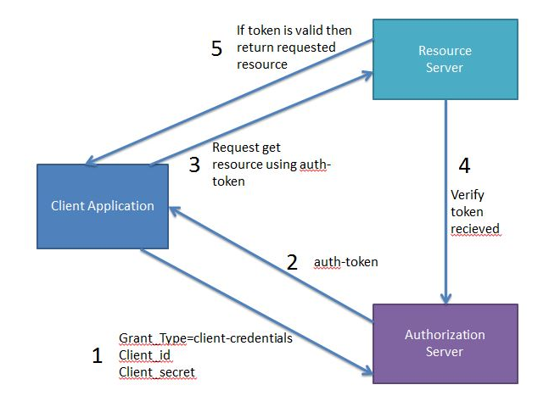

Code Example:-

Authorization Server(1st boot application)
Lets first create the Authorization Server which will generate a token for client. Maven Project will be as
@RestController
@EnableResourceServer
@SpringBootApplication
public class Application {

public static void main(String[] args) {
SpringApplication.run(Application.class, args);
}

//This method will be used to check if the user has a valid token to access the resource
@RequestMapping("/validateUser")
public Principal user(Principal user) {
return user;
}
}
Configure the Authorization Server. The @EnableAuthorizationServer annotation is used to configure the OAuth 2.0 Authorization Server mechanism and defines the behaviour of various endpoints when interacting with the authorization server.
@Configuration
@EnableAuthorizationServer
public class AuthorizationServer extends AuthorizationServerConfigurerAdapter {

@Autowired
private AuthenticationManager authenticationManager;

@Override
public void configure(AuthorizationServerEndpointsConfigurer endpoints) throws Exception {
endpoints.authenticationManager(authenticationManager);
}

@Override
public void configure(ClientDetailsServiceConfigurer clients) throws Exception {
clients.inMemory().withClient("javainuse-client").secret("javainuse-secret")
.authorizedGrantTypes("client_credentials").scopes("resource-server-read", "resource-server-write");
}
}

Resource Server(2nd boot application)

Next create the Resource Server which has the reource to be accessed by the client. Maven Project will be as follows-

Define the Spring Boot Main Application. Configure the Resource Serverusing @EnableResourceServer annotation. It means the service expects an access token in order to process the request. Access token should be obtained from Authorization Server by OAuth 2.0 Client before calling the Resource Server.
@EnableResourceServer
@SpringBootApplication
public class Application {

public static void main(String[] args) {
SpringApplication.run(Application.class, args);
}
}

Define the Controller, to expose API which can be accessed only using valid token.
@RestController
public class TestController {

@RequestMapping("/test")
public String test() {
return "Hello World";
}
}

Next define the url of the authorization server to be called by the resource server for verifying the token in the application.yml as follows.
security:
oauth2:
resource:
userInfoUri: http://localhost:8080/validateUser
server:
port: 9090
Finally start the Authorization Server and the Resource Server.
- First get the Access Token by making a POST request to localhost:8080/oauth/token
  - Specify the client_id and client_secret in the header using base64 encoding.
  - Next specify the grant type as Client Credentials in body and send the request.
We get the token as response
- Get the Resource using the access token received above and making a GET call to localhost:9090/test.
The token is specified as Authorization Bearer.

